Points in „Amoeba as vehicles of bacteria“

Introduction:

* Man-made system, especially cooling towers as reservoir for potential human pathogens
* Describe candidates of those human pathogens
* Disinfection measures and their efficiencies:  
  Chemical disinfection (chlorine derivates), UV, temperature  
  Known effect of chlorine on FLA and pathogens
* What are FLAs and resistance to external stress
* Protection of intracellular bacteria / amoeba-resisting bacteria => emerging pathogens
* Protection provided by other protists: Ciliates also may act as hosts for Legionella (Fields et al 1984)
* Dynamic in system: when looking at the total picture
* Brief description of the experimental setup:  
  Two/three cooling towers => amplicon approach => results

Results:  
  
General Sequencing results:

* Describe how many PCRs has been done, how average number of reads obtained before and after trimming and quality filtering.

Richness and complexity: Subset “Protists” with classification score 60

* Richness and Complexity:  
  Complexity at genus-level OTUs, Shannon and Evenness indices at 97% sequence similarity cutoff for each sampling-location.  
  - Combined 16s and 18s  
  - 16S  
  - 18S
* Changes in richness with time.  
  Changes in relative abundance within a single location.
* 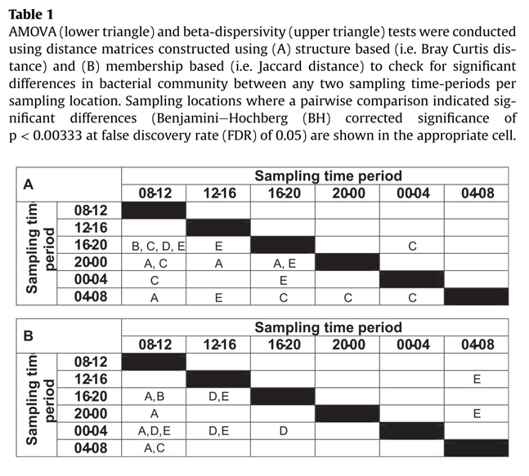Bacterial community structure:  
  Bray-Curtis (structure based => change in relative abundance) and Jaccard Analysis (membership based => presence / absence): Between each season at all sampling location:   
  NMDS plots.   
  PCoA plots  
  No need to use table.
* Core and Unique Genus-OTUs:  
  Venn diagram analysis: X number of OTUs are shared and accounted for Y percent of total classified sequences.  
  What are these shared OTUs?  
  Which taxa are unique for each location?  
  Which dominating taxa for each location?

Bacterial specific:  
Repeat analysis from above

* Low diversity and occurence of Legionella-OTUs
* Occurence of Pseudomonas and Mycobacteria.
* Partial 16S trees for OTUs of interest

Protist specific: which hosts are interesting  
Repeat analysis from above

* 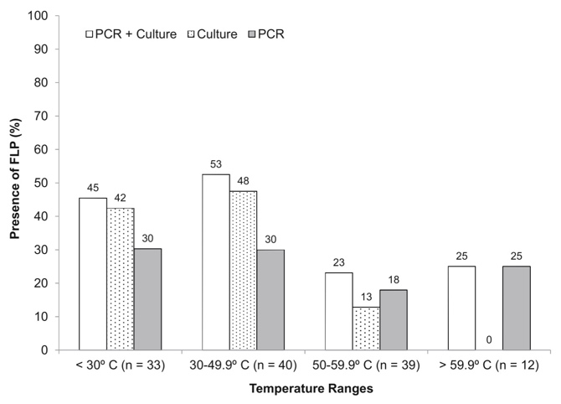Combining qPCR data with amplicon data:  
  How many samples are positive with which method. Do the methods agree with each other? Discuss the sensitivity of different methods: more Hartmannella taxa with amplicon?
* Most FLAs found are *Acanthamoeba, Vahlkampfia, Vannella, Vermamoeba.* Not too much information about flagellates and ciliate species that inhabit man-made water systems are known => describe this system

Correlation-part:

* Describe the most significant correlation (pos and neg)
* Which protists taxa are correlated to certain known amoeba-associated bacteria
* Higher correlation between certain amb-ass taxa with protists
* Does the KBE correlate with richness? Check
* Network visualization
* Correlation of seasons or other environmental with the taxa

Discussion:

* (Discussing the lack of replication: It has been shown that the lack of technical replication is an important issue.) Ask the other groups
* Which database has been used for classification and which cutoff for positive classification.   
  Definition of protists and which taxa as „Amoeba-associated“ bacteria.
* Richness: verglichen mit anderen Freshwater systems.
* Discussing the shifts in bacterial and eukaryotic community  
  how does in temperature, disinfection, external influx etc. play a role.
* Discuss abundance of potential human pathogens
* Discussing the meaning of correlation between the taxa
* Discuss potential biofilm formers and measures to counter-act formation
* Discuss detection difference of protists between qPCR and amplicon approach
* Design of future microbiome studies?

Combine results + discussion as one paragraph  
16s remove organelles:

**Add plots and one sentence of result to each point.**